**Day 1 - AWS - Cloud Computing & IAM**

Different types of cloud computing:

* It’s an umbrella term
* Cloud computing categorized by, below are all cloud providers

1. **Infra structure as service** :(organisation only focus on this only).

Renting this infrastructure in AWS.ex: compute (ec2 hardware mechine, storage (s3),network (vpc).all are hardware ..we have renting all from AWS.pay as go model followed by AWS. We have to pay everything and get. We have to **develop an application**, built it in ec2 then developer can develop app..aws serves as an infra

1. **Platform as service**:

Infra +platform. AWS provides infra along with platform (java, python,load balancer, AWS elastic beanstack).just upload the application , remaining things taken by AWS

1. **Software as service**:

Infra +platform+application. We can use the application. Ex: google workspace (Google drive,photos,mail…), software upgrade. All maintained by AWS

**Ec2 pricing model:**

<https://aws.amazon.com/ec2/pricing/>

<https://www.geeksforgeeks.org/pricing-models-for-amazon-ec2/>

**Types of instances:**

1. General purpose instance ( T3 micro,t series ,M series)
2. Compute optimised .for gaming application iot application use this instance.cpu power is high (c series)
3. Storage optimized .application required more data space use this (I ,D series)
4. Memory optimized .application should be very fast .**if your application is memory intensive and deliver fast performance use this (R,X series)**

Ec2 🡪 instance type. According to our requirement select instance type.

While connecting ec2 machine, that open via browser. But is not safe while working in an organization. For securely opening we need protocol.

**In your local machine you have to install the remote tool (gitbash , powershell) from the remote tool you will be connecting to your Ec2 mission using the Ssh connection. So click on Ssh client. Follow the steps given below. copy command chmod and run in gitbash**

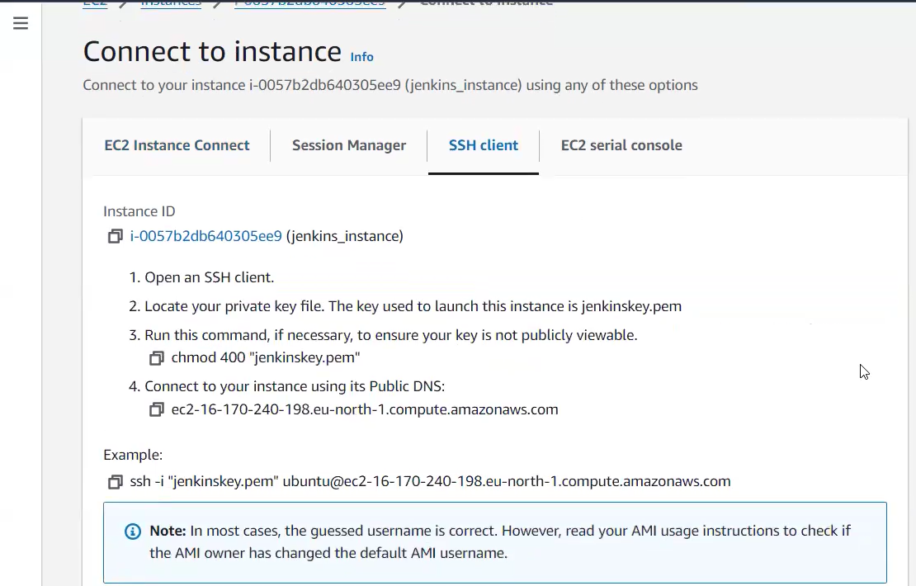

Ssh -i(identity file ) by .pem key is identity file. Ubuntu is an username . @ ip address of an ec2 mechine.

**AWS CLI:**

It means aws command line interface .It is an amazon web services tool that enables to control amazon public cloud services by typing commands on a specified line.

Here, we create any aws service through AWS CLI. Its can be downloaded in windows,linux,mac.

**how to install the cli from your Linux machine**:

launch new instance. open ec2 machine via browser without keypair we have to run ec2.but its not safe. We can also used already generated key also.

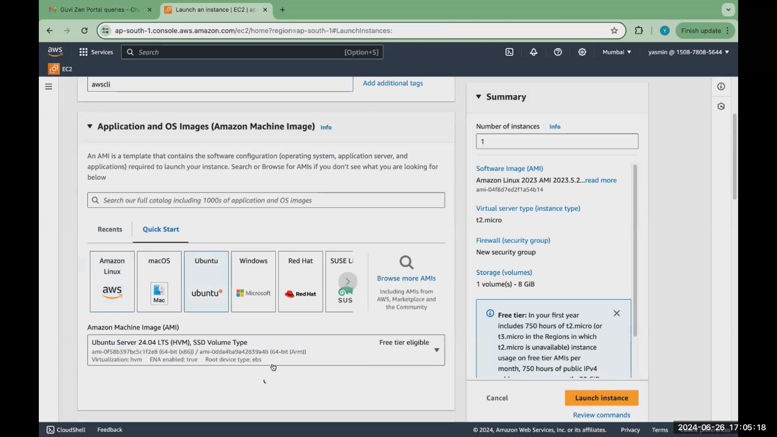

Give connect

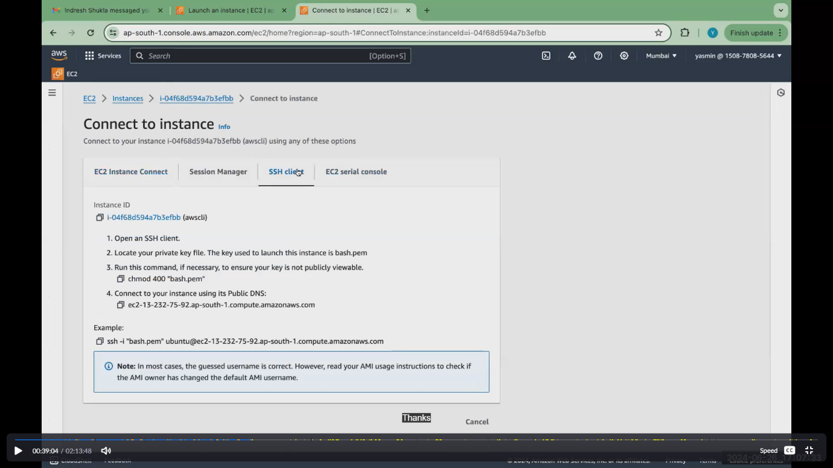

**How to install aws cli documentation**:

<https://docs.aws.amazon.com/cli/latest/userguide/getting-started-install.html>

Execute this command in command prompt or PowerShell. Below 2 commands in our ec2

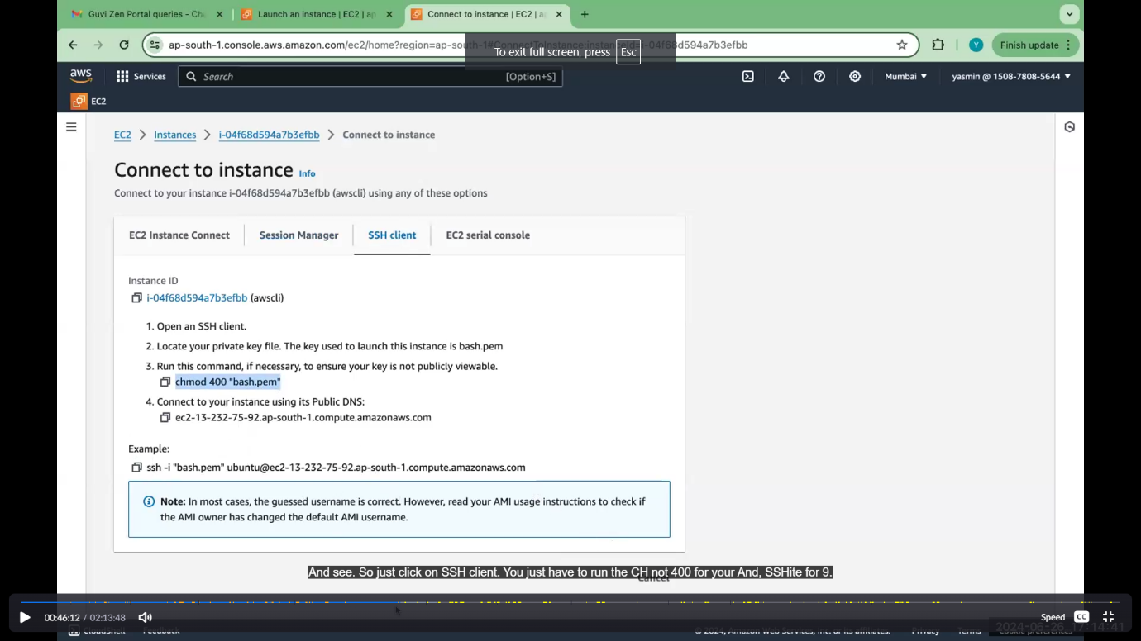

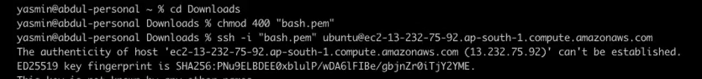

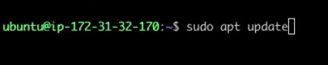

**Install aws cli command**

sudo apt install awscli -y

this cmd used for install AWS cli in linux.

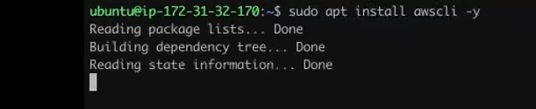

In some ubuntu me, sudo apt install not work..at that time use below cmd

curl "https://awscli.amazonaws.com/awscli-exe-linux-x86_64.zip" -o "awscliv2.zip"

unzip awscliv2.zip

sudo ./aws/install

connect with ec2 for check AWS CLI installed or not.

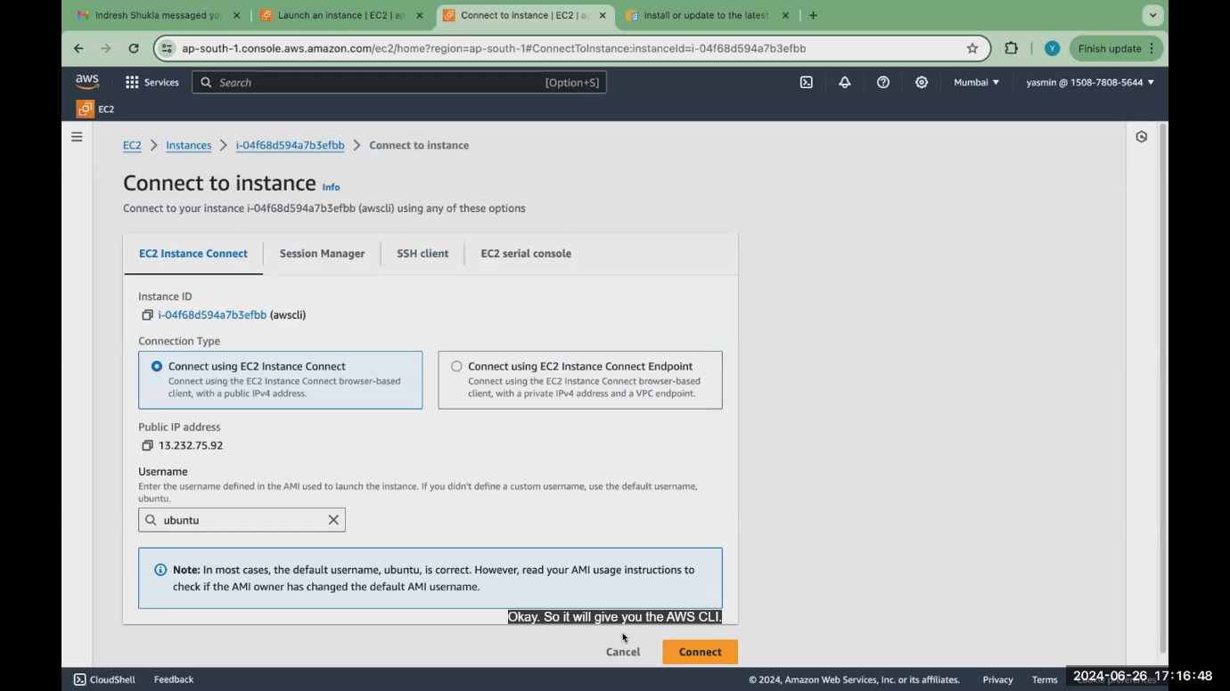

aws --version cmd used to check AWS CLI installed or not

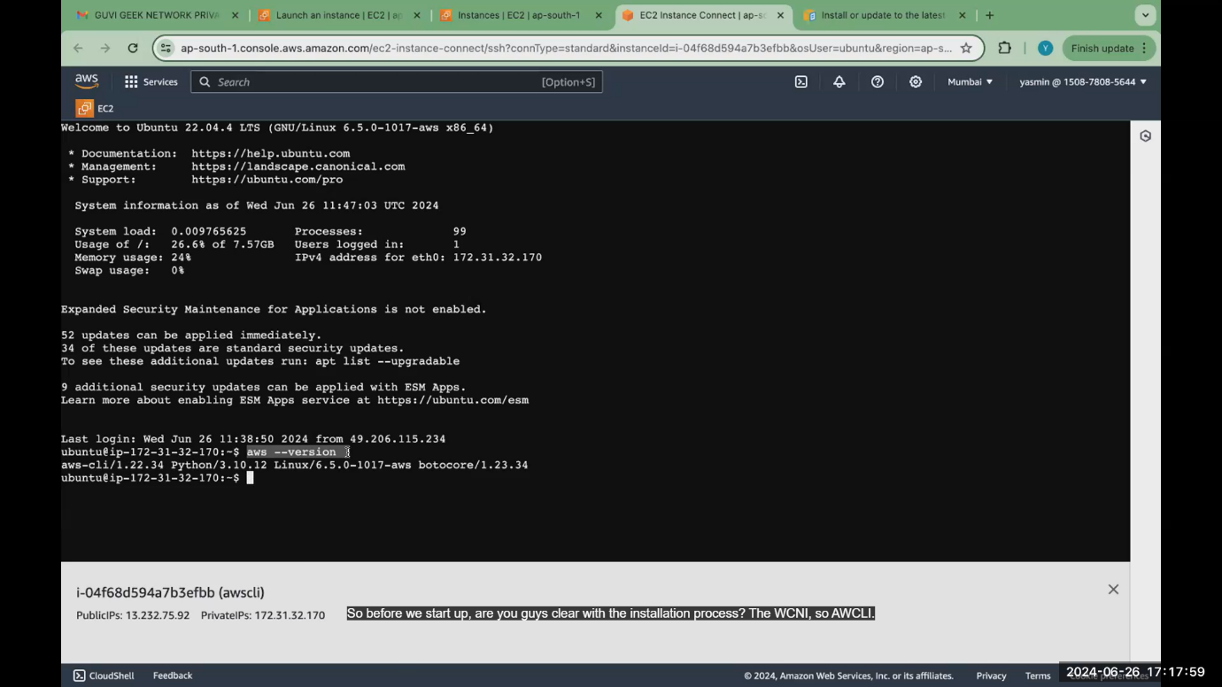

**What is IAM?**

* It an IDENTITY AND ACCCESS MANAGEMENT.
* ec2 comes under compute service.
* IAM comes under security services.
* Team lead have the root account.
* We will be creating an IAM account for all the users.
* So, it is like you share a same account with multiple users.
* **This root account will be managed or controlled by your administrator team or someone or team lead will be managing your root account. So, we don't share the root account to all the employees.**
* **you can create groups. So you can have developer group, Hr group, testing group. What are all permissions you give to the developer group will be applicable to the to the user that is there in the developer group.**

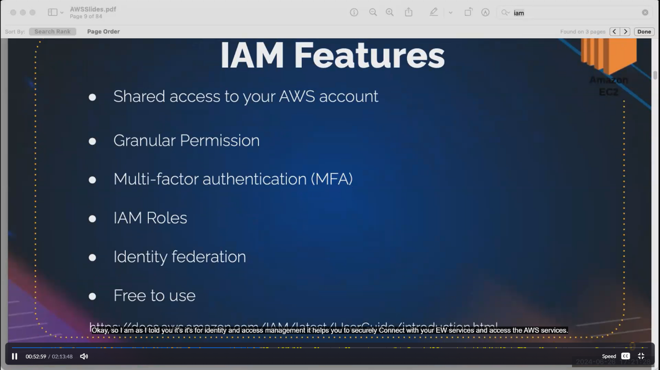

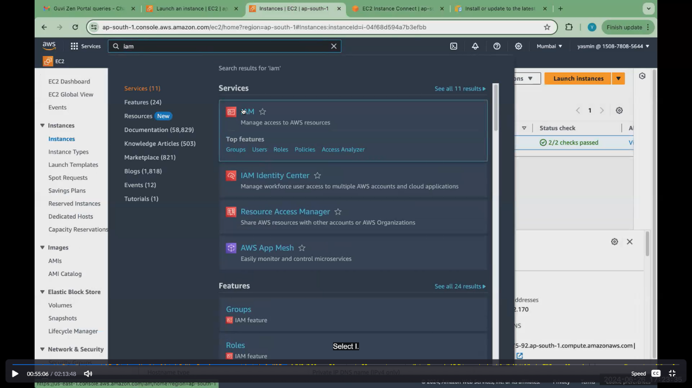

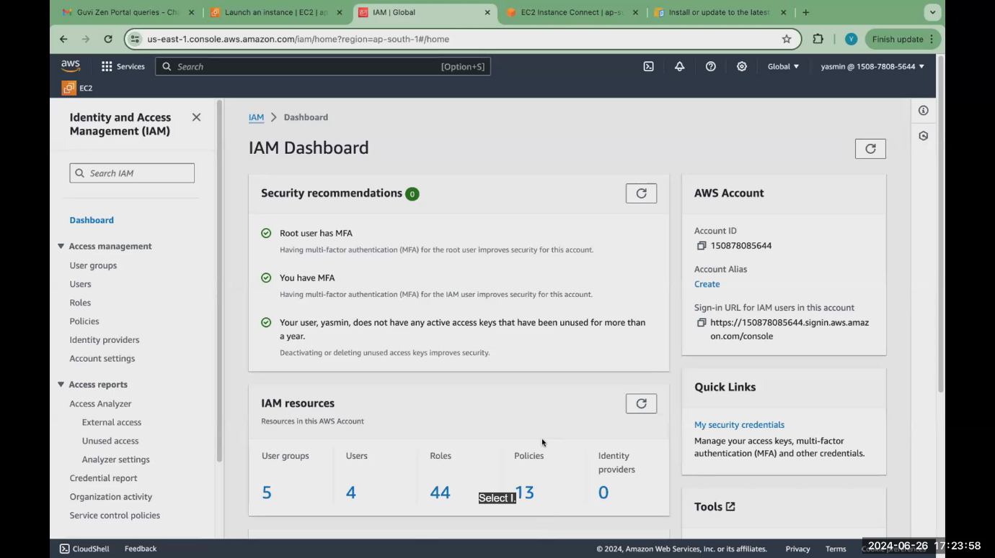

Only the root user shows about billing details

**components are main components**

* **user groups, roles and policies, users.**

1. **Create a user:**

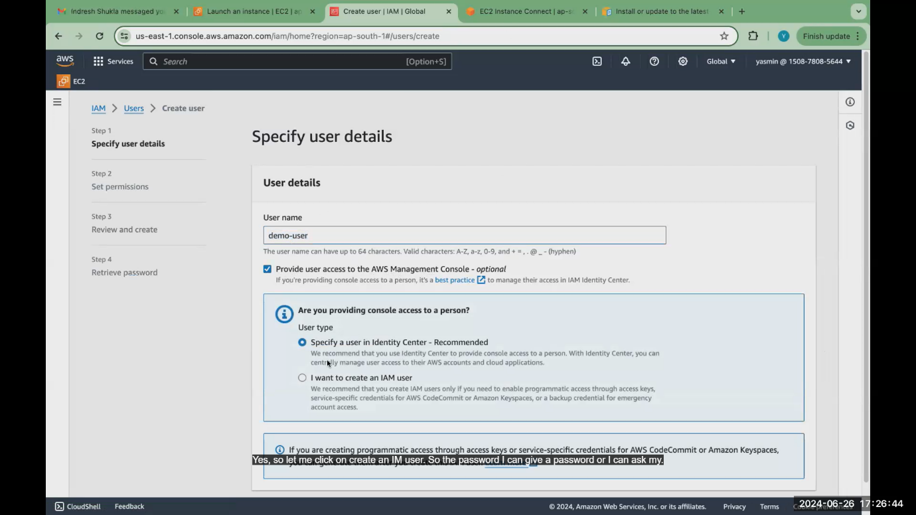

Give custom password. Suppose give auto generated password 🡪select users must create option🡪click next

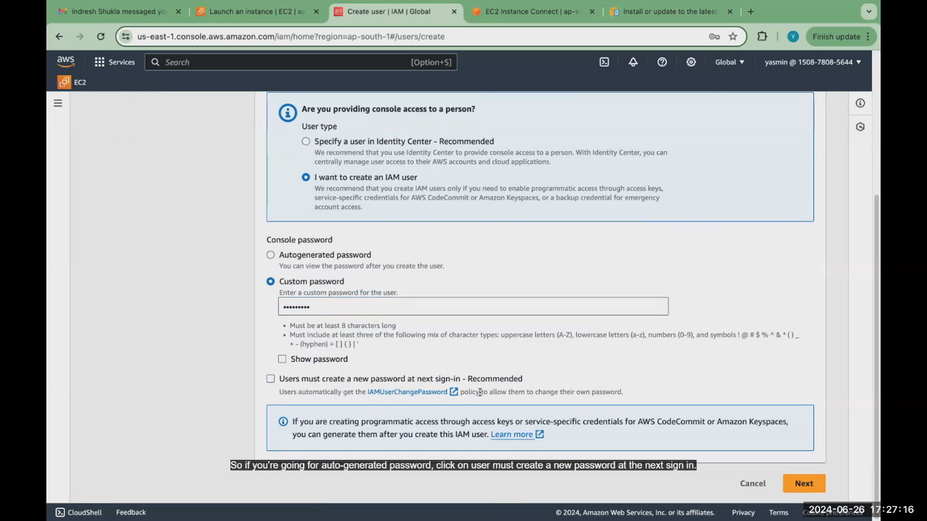

Set permission for demo users:

1. **ec2 full access**

* that users cant add in any user group. he is an individual user.
* Add only policies. Give only ec2 full access. He can launch instance ,stop ,start only.

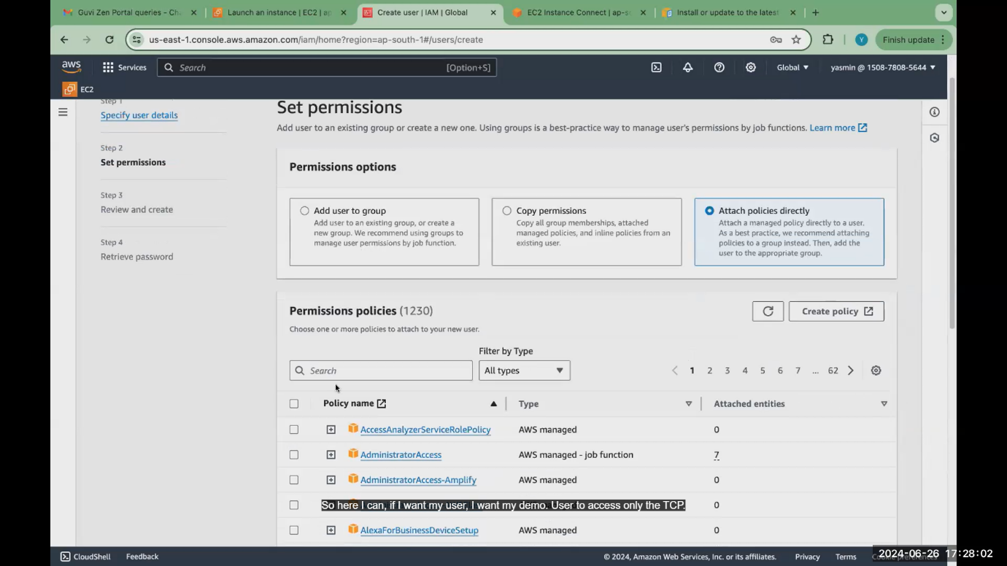

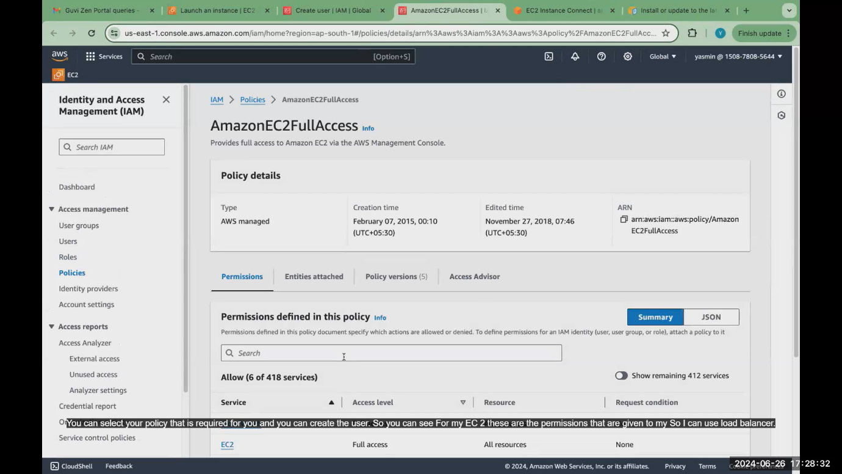

1. **S3 bucket access**:

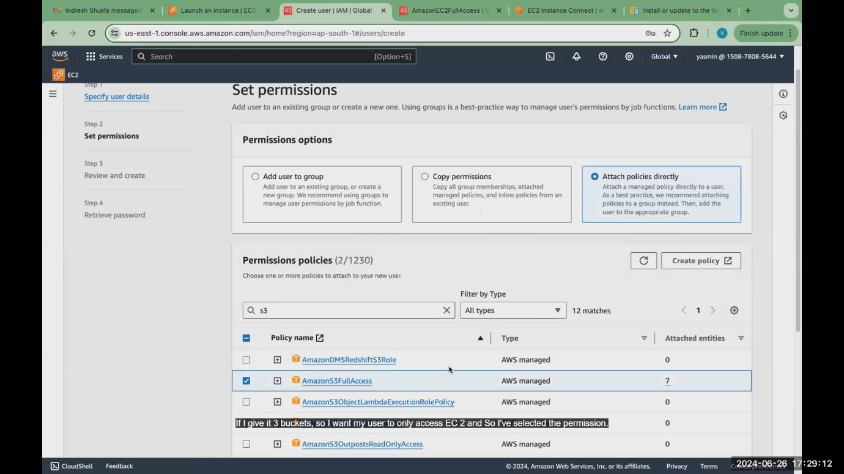

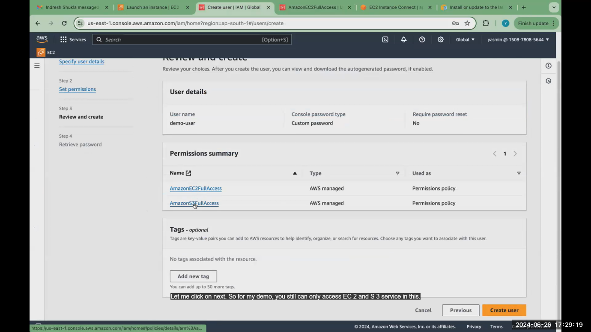

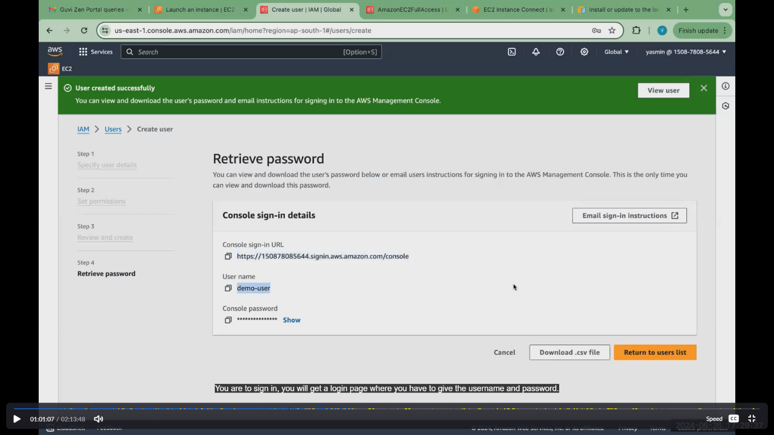

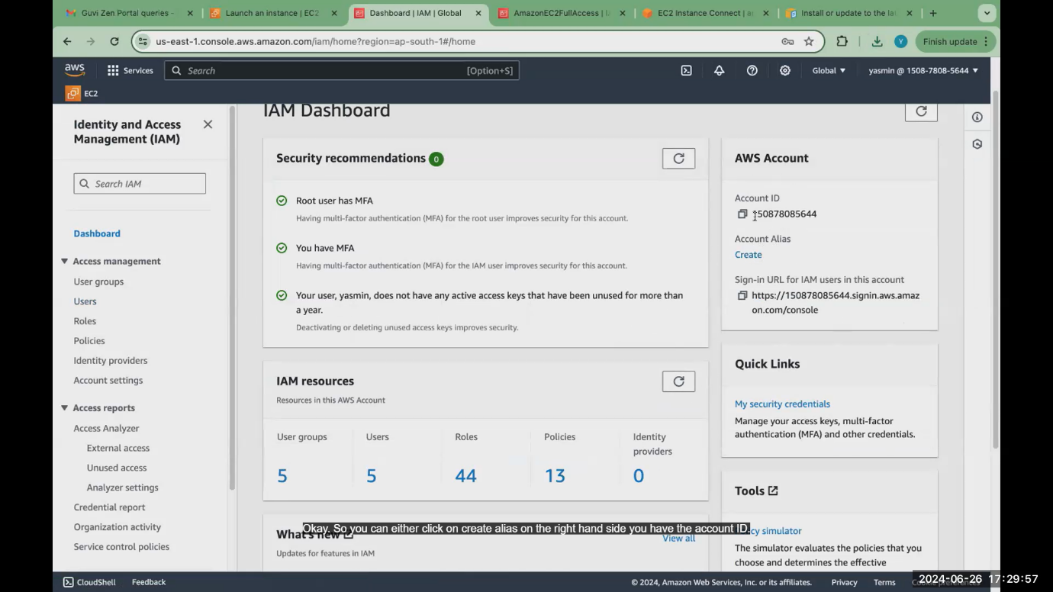

Click create alias .get iam user name ..give iam id details while login .sometimes we forget .so create alias

Login as a demo-user:

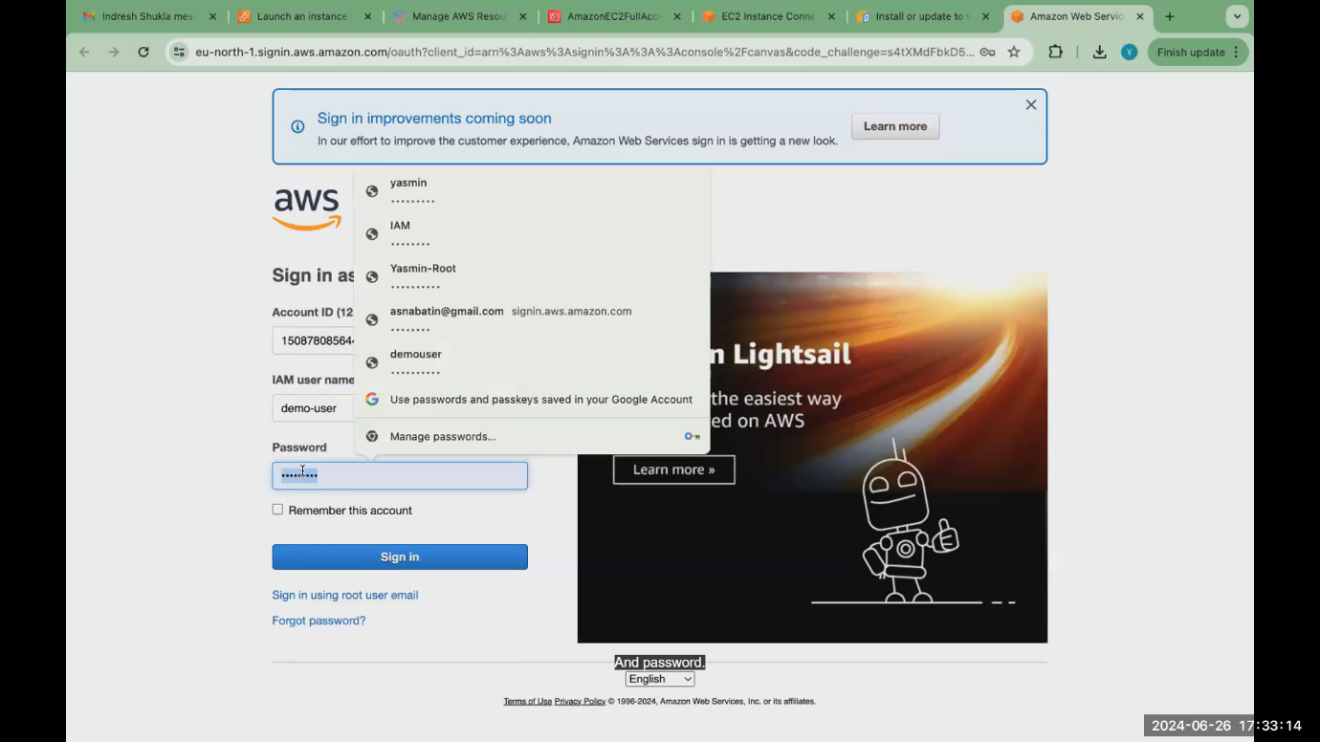

Give permission only for ec2 ,s3 only. This permission not give so shows error

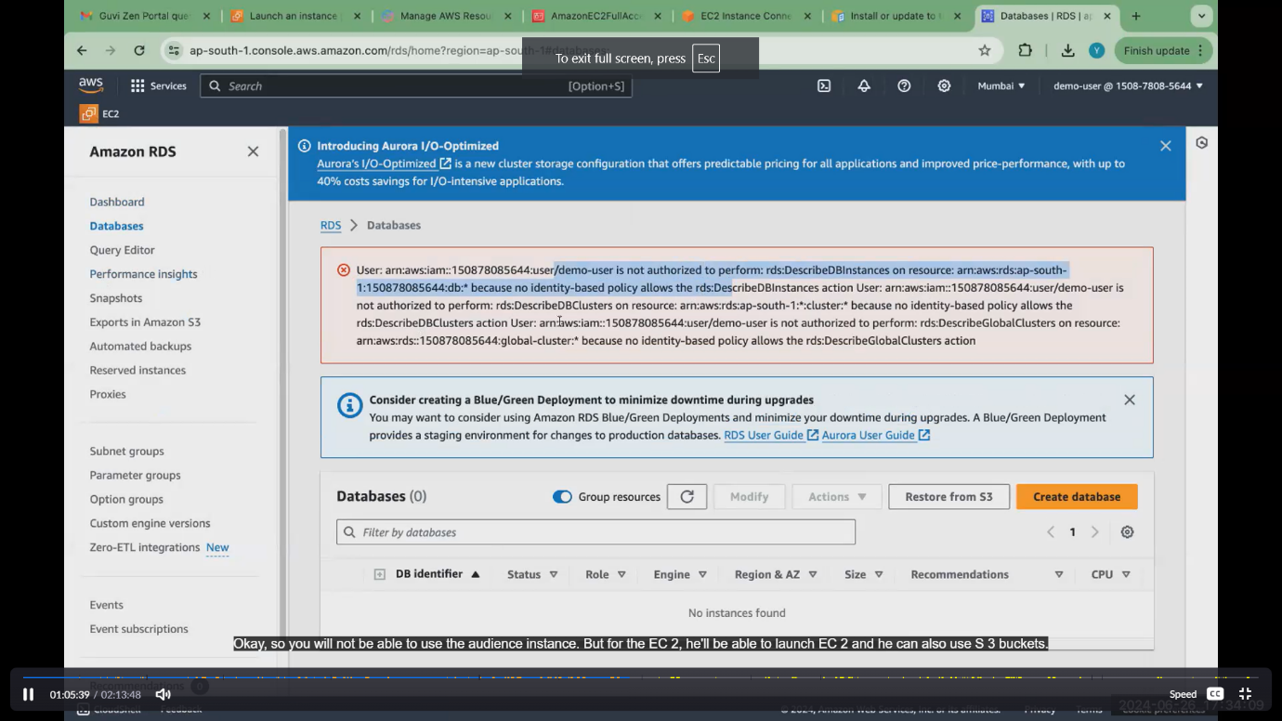

Create s3 bucket:

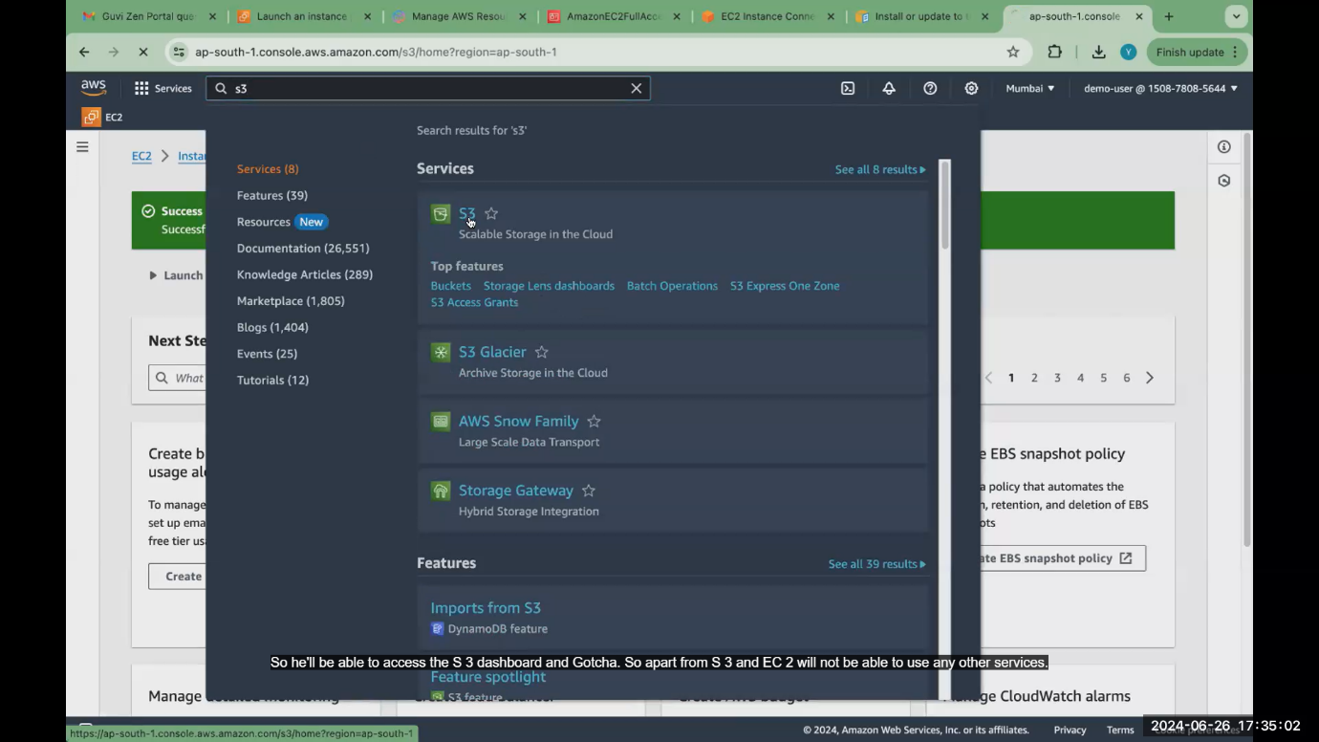

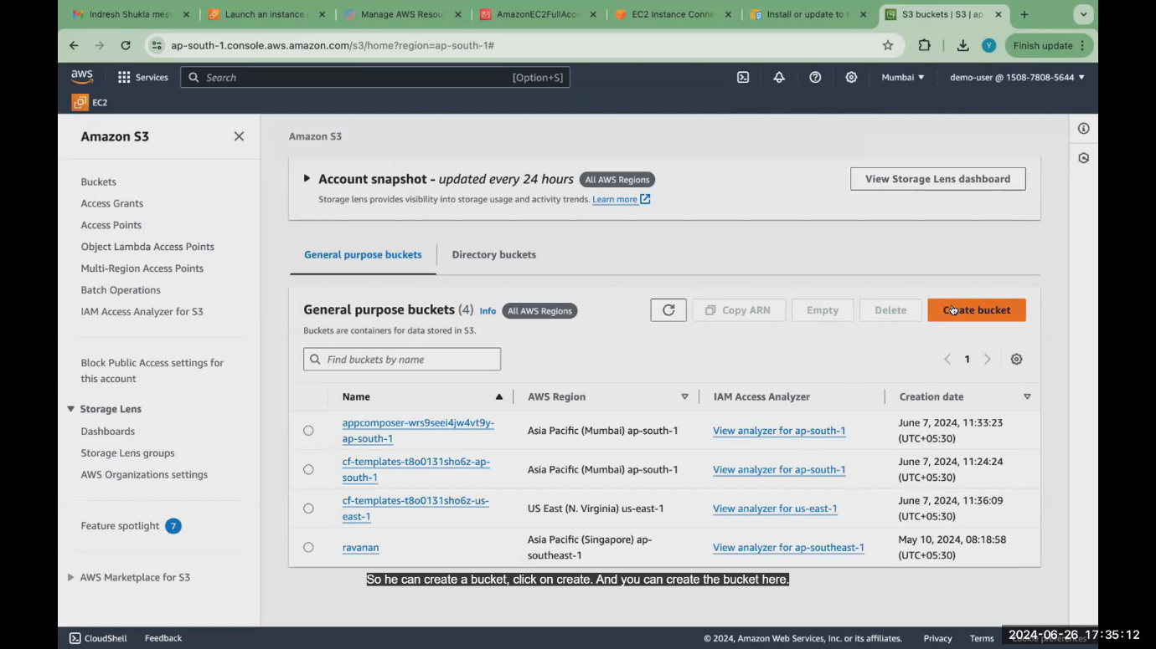

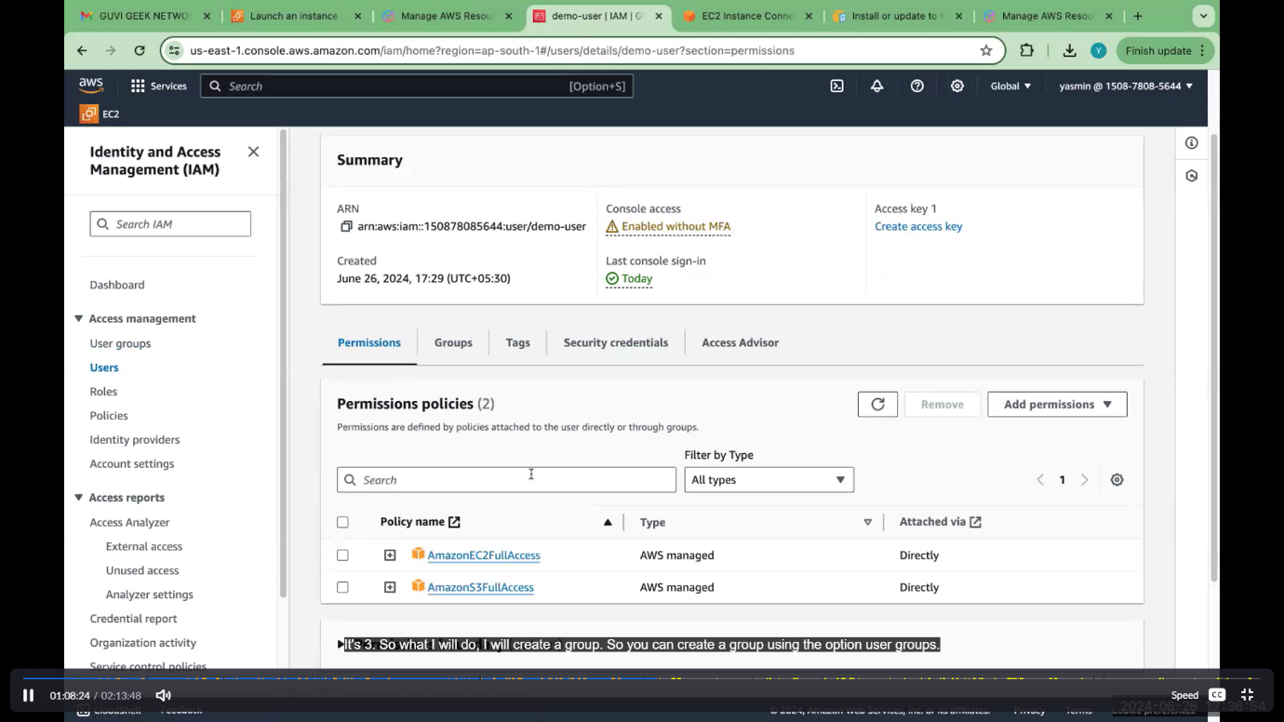

1. **Create user groups:**

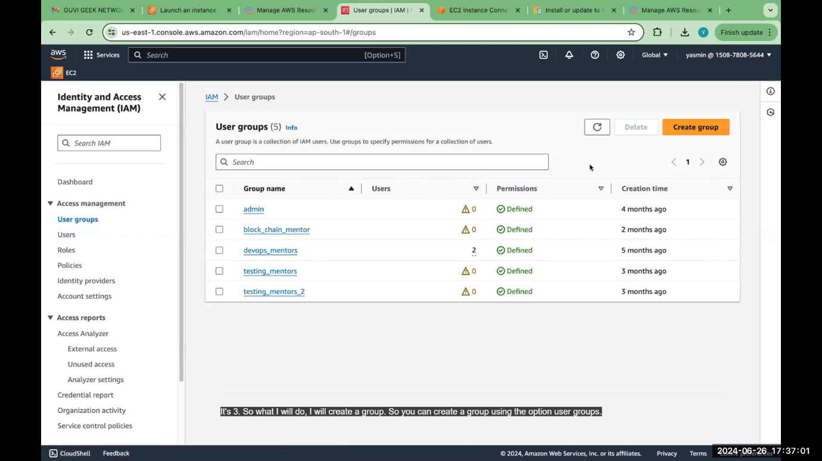

**Add 2 users in that group**

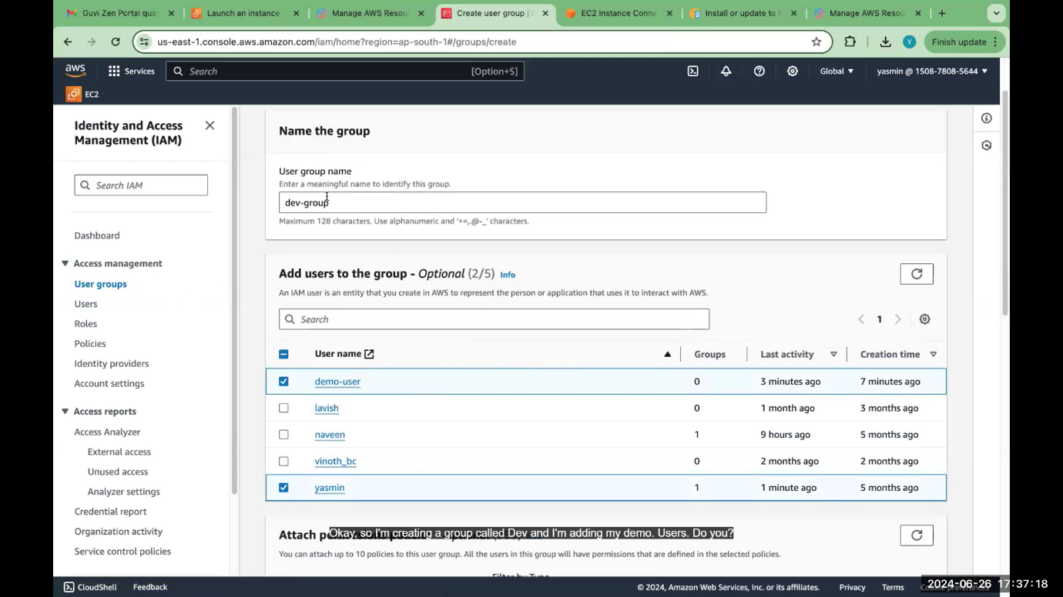

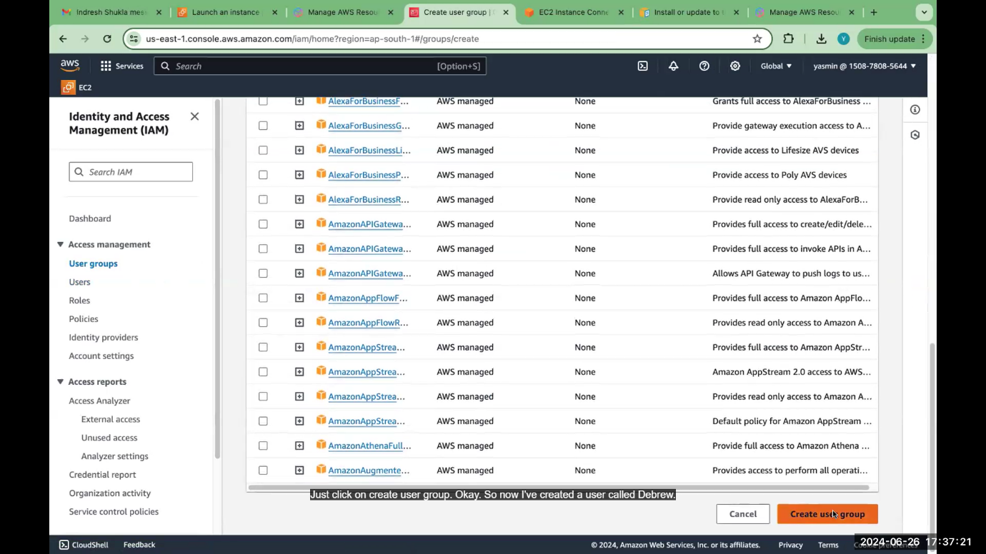

**User group created**

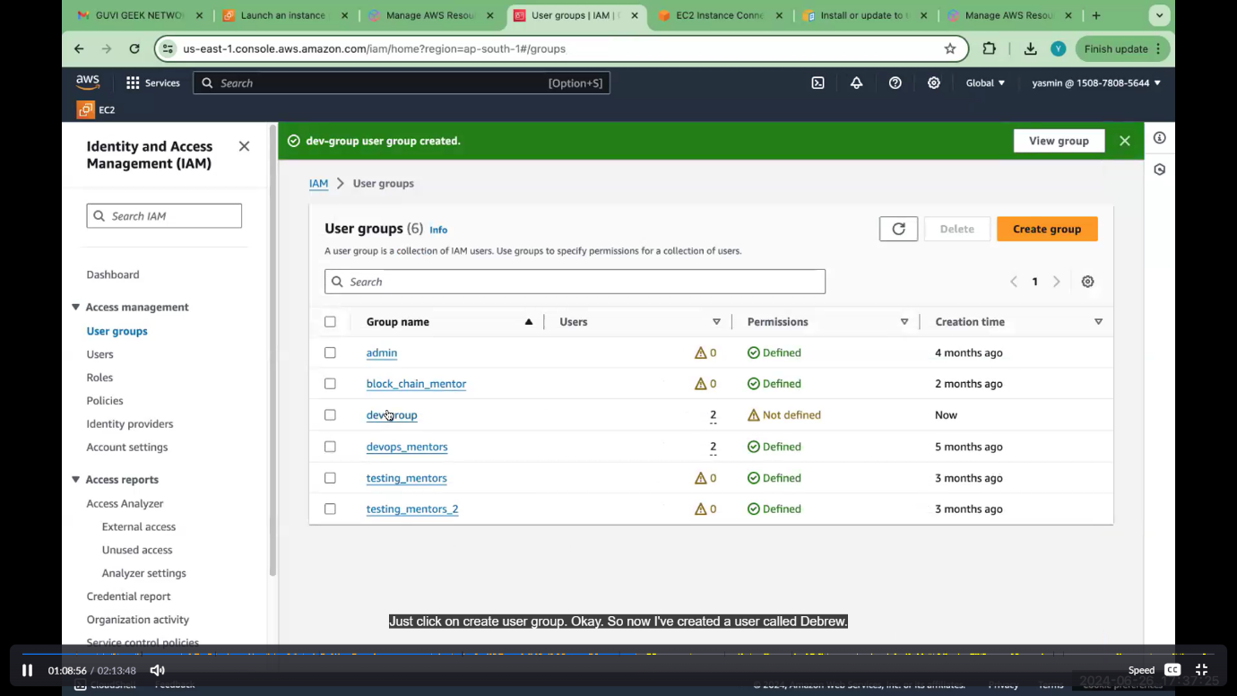

**Add permission for dev group (administration access)**

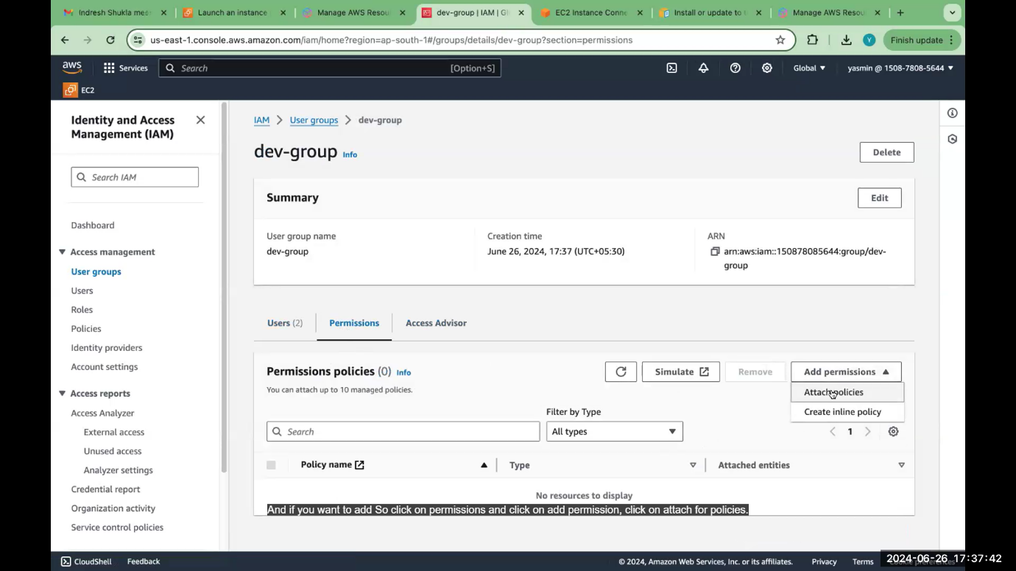

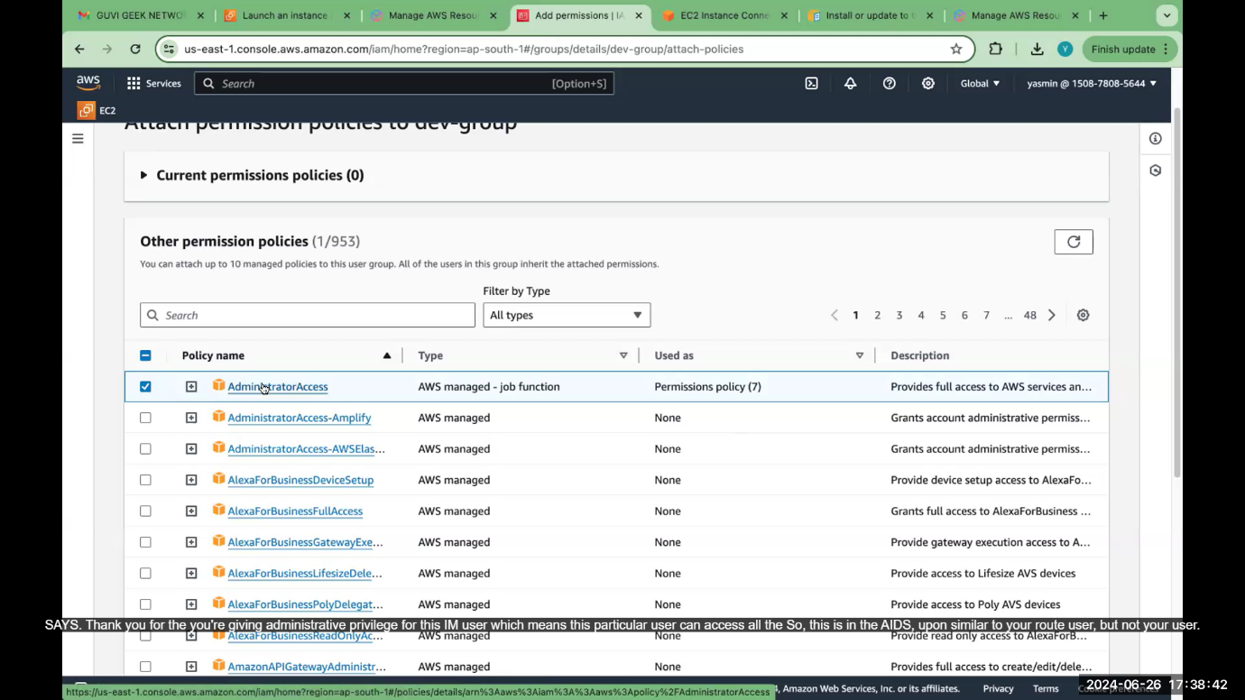



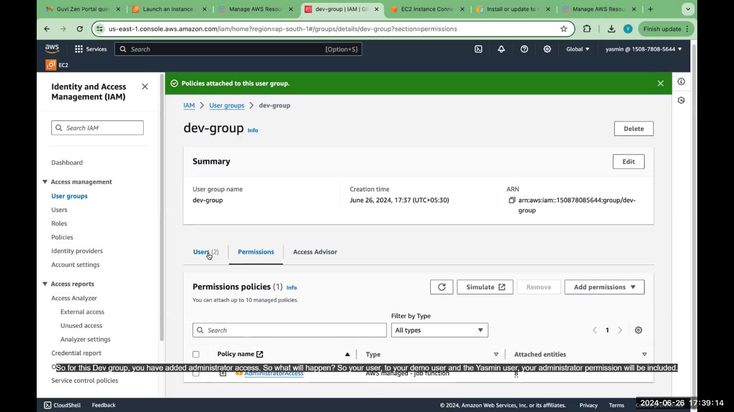

**Add demo user in user group .so that user get administration access permission also.**

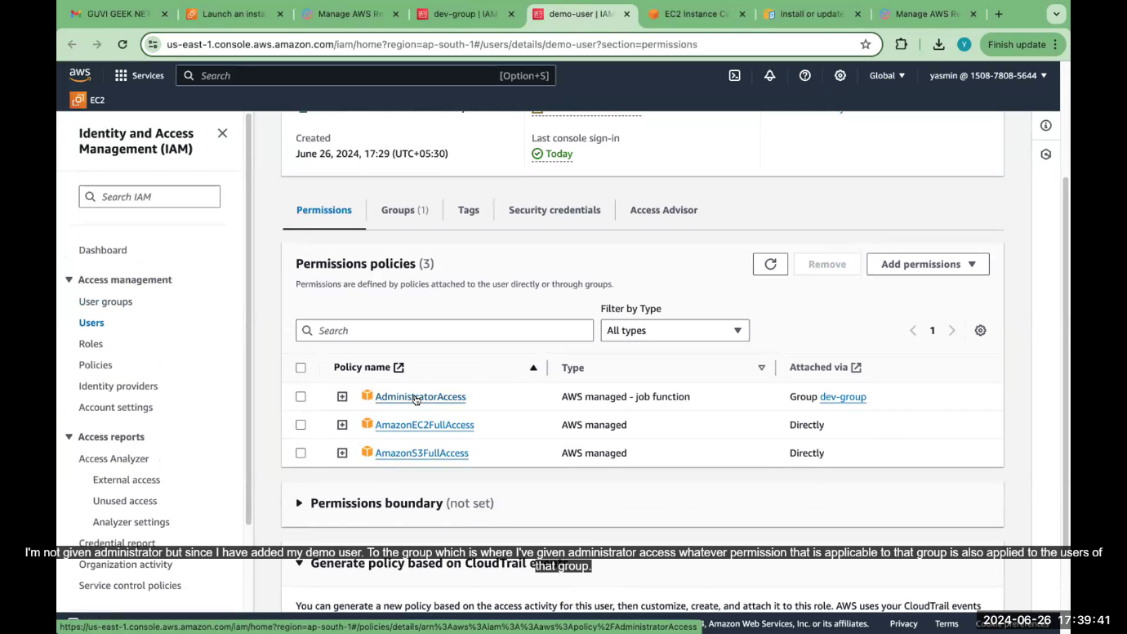

**Suppose delete this user. click delete option**

